BUSINESS ANALYTICS PROJECT
OVERVIEW REPORT

Predicting and Reducing Missed Referral Appointments at Jigjiga University Sheikh Hassan Yabare Comprehensive Specialized Hospital

BAN6800 – Module 2 Assignment

Prepared by: Mr. Abdi Farah Ahmed
Nexford University

Sep-14-2026

1. Business Problem Definition

Module 1 identified a particular capacity problem: when a referred or follow-up patient does not attend, the patient may suffer delayed care whilst also losing a scarce specialist slot. JJUSHYCSH is the tertiary referral hospital for the Somali Region, which serves a geographically dispersed population, so avoidable non-attendance can affect both access and throughput (Ahmed, 2026; CURE Ethiopia, 2023; JJUSHYCSH, n.d.). The planning problem today is more than just “predict no-shows.” It is to create a reliable process for translating scheduling data into timely and equitable outreach decisions 24-72 hours prior to an appointment.
The problem-identification framework is applied as follows. Define: missed referral/follow-up appointments reduce specialist-slot utilization and create avoidable clinical and operational risk. Gather data: Module 2–4 development will use the Medical Appointment No Shows dataset, which contains 110,527 appointments and 14 variables; Module 3 will also define the minimum local OPD/referral extract required for later validation (Hoppen, 2016). Analyze: descriptive analysis will quantify no-show patterns, scheduling lag, age, gender, chronic-condition flags, and reminder exposure. Root cause: because local outcome data are not yet available, the initial RCA is explicitly a set of hypotheses to test rather than a claim that the Brazilian proxy proves Jigjiga-specific causes. Objectives: create a reproducible risk pipeline and outreach workflow that can later be recalibrated on local data.
The primary business KPI remains a relative reduction of at least 15% in the local no-show rate within two quarters of deployment, measured against a Module 3 hospital baseline. The model KPI is at least 70% recall for the high-risk no-show class. Supporting KPIs are specialist-slot utilization, percentage of high-risk appointments reached within the outreach window, staff time spent manually reviewing lists, and fairness gaps in true-positive and false-positive rates across monitored groups. No improvement claim will be made from the proxy dataset alone.

Business and Analytics KPIs
KPI | Definition | Target | Use
No-show rate | Completed missed appointments ÷ scheduled appointments | ≥15% relative reduction within two quarters after local deployment | Local baseline established in Module 3
High-risk recall | TP ÷ (TP + FN) for no-show class | ≥70% | Prioritizes finding patients who need outreach
Specialist slot utilization | Completed visits ÷ scheduled visits | Increase vs. baseline | Business throughput outcome
Outreach timeliness | High-risk appointments contacted in 24–72h window ÷ high-risk appointments | ≥90% proposed pilot target | Leading operational KPI
Fairness gap | Max–min TPR by monitored group | ≤0.10 proposed release threshold | Report FPR gap and selection rates too

2. Root Cause Analysis
Figure 1 demonstrates the project fishbone analysis, and it organizes the working causes into five domains: patient/access barriers, scheduling workflow, data/technology, communication/outreach, and governance/capacity. These hypotheses are based on the context of Module 1 long-distance access, limited reminder resources, incomplete digitization, connectivity constraints, and the lack of an analytics-based prioritization process must be tested against local records and stakeholder interviews before operational conclusions are made (Ahmed, 2026).
A 5-Whys chain clarifies the controllable root problem. Why are specialist slots lost? Because some scheduled patients do not attend and replacements are not always identified early. Why is outreach unable to focus on the most at-risk appointments? Because staff do not have a ranked risk list. Why is there no ranked list? Because scheduling and attendance data are not yet transformed into a repeatable prediction pipeline. Why is that pipeline absent? Because data are fragmented, local data access requires governance approval, and the hospital has limited data-science capacity. Why does this matter operationally? Because scarce reminder resources are applied without risk-based prioritization. The project therefore addresses a root capability gap—turning routine scheduling data into governed, timely decision support—while recognizing that transport cost, distance, language, or other patient barriers may require service interventions beyond analytics.
Each RCA hypothesis maps to data requirements. Scheduling-lag hypotheses require scheduled and appointment dates; outreach hypotheses require SMS/phone-contact status and outcome; repeat-attendance hypotheses require pseudonymous patient and prior-visit history; access hypotheses require ethically approved geography or distance bands; and fairness analysis requires protected or vulnerability-related attributes used for auditing, not service denial. The causal analysis will be revisited at the end of Module 3 after exploratory analysis and local stakeholder feedback.
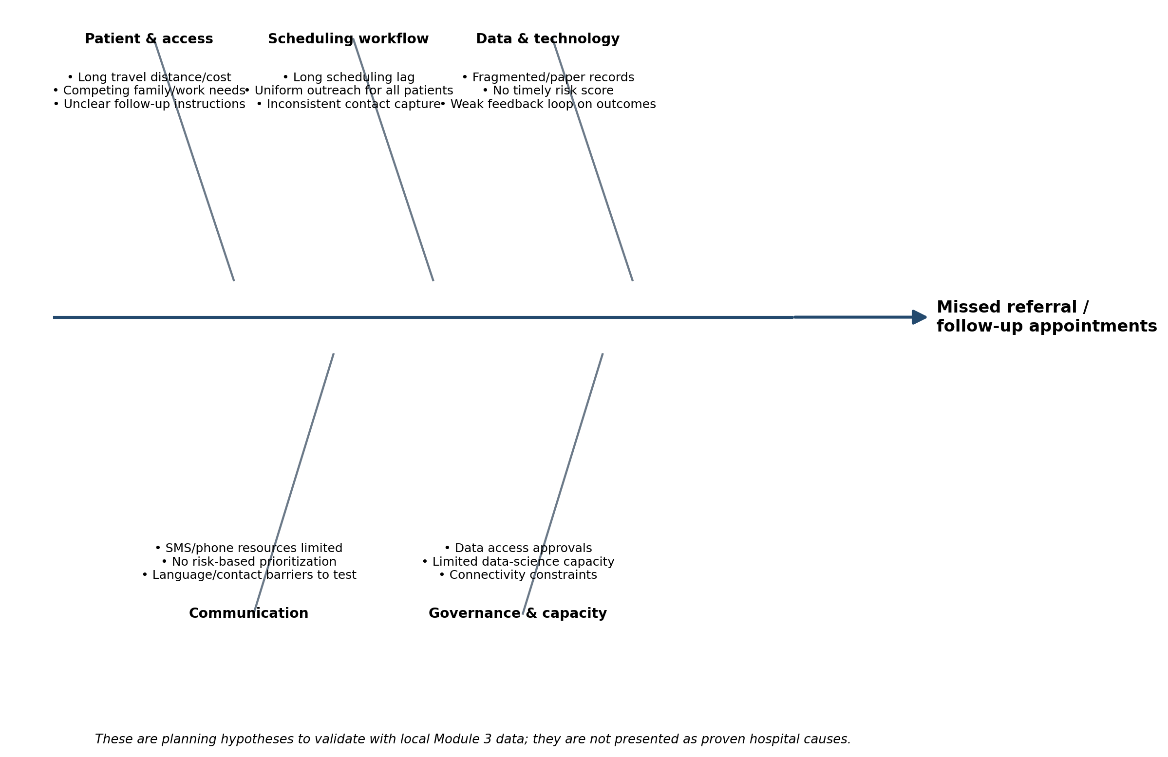
Figure 1. Fishbone root-cause hypotheses for missed referral/follow-up appointments.
Why | Question |  | Planning finding
1 | Why are specialist slots lost? |  | Some scheduled patients do not attend and replacement opportunities are missed.
2 | Why is outreach not focused? |  | Staff lack a ranked list of appointments most likely to become no-shows.
3 | Why is there no ranked list? |  | Scheduling/attendance data are not transformed into a repeatable risk pipeline.
4 | Why is the pipeline absent? |  | Fragmented digitization, data-access approvals, and limited analytics capacity.
5 | Why is this a root capability gap? |  | Limited outreach resources cannot be allocated by risk and outcomes are not fed back systematically.
Priority hypothesis / capability gap | Data needed to test or monitor | Primary KPI linkage |  | Design response
Scheduling lead time contributes to missed visits | ScheduledDay, AppointmentDay; future local scheduling timestamps | No-show rate; high-risk recall |  | Engineer lead-time/day-of-week features and inspect non-linear effects.
Reminder/outreach is not targeted or timely | SMS_received; future reminder type, contact time and outcome | Outreach timeliness; no-show rate |  | Track intervention exposure and use risk tiers to prioritize approved outreach.
Fragmented digitization limits reliable risk scoring | Required-field completeness, duplicate/invalid records, attendance-label completeness | Data completeness; batch success |  | Apply a data-quality gate before modeling or scoring.
Access barriers may create unequal model errors | Ethically approved age/gender and future coarse geography/distance bands | TPR/FPR gaps; equal opportunity |  | Use attributes for auditing/support design; investigate disparities before release.
Table 2. Root-cause hypotheses linked to data needs, KPIs, and design responses.

3. Business Analytics Project Overview and Technical Architecture
The project objective is to deliver a reproducible analytics product that scores each scheduled referral/follow-up visit as Low, Medium, or High no-show risk and recommends a proportionate outreach action under a fixed resource constraint. In scope are data ingestion and validation, descriptive and diagnostic analysis, feature engineering, baseline and tree-based classification models, threshold selection, fairness assessment, SHAP explanations, risk-tier rules, a role-based dashboard, audit logging, and documentation. Descriptive and diagnostic analysis establish patterns and data-quality issues; predictive modeling estimates no-show risk; and a rule-based prescriptive layer maps approved risk tiers to outreach actions. Out of scope are diagnosis, clinical triage, automatic cancellation, automatic deprioritization, or any use of risk scores to reduce access to care.
The main deliverables are: (1) a private GitHub repository using the Module 1 structure; (2) requirements.txt and reproducible setup instructions; (3) a preliminary data dictionary and data-quality rules; (4) an ETL and feature pipeline; (5) a benchmark model and tuned candidate model; (6) a model card with performance, calibration, fairness, and limitations; (7) a prescriptive outreach rule; (8) a Streamlit or Power BI dashboard prototype; and (9) governance artifacts including the privacy plan, RAID log, compliance checklist, and separate AI Disclosure Form. The public Kaggle proxy is a static development source. For future local implementation, the JJUSHYCSH HIS/data officer is the operational data steward, and approved scheduling/attendance extracts are intended to refresh daily so scores can be generated within the 24–72-hour outreach window.
Figure 2 formalizes the architecture. During development, the Kaggle dataset enters through Python/pandas validation and is versioned with DVC. A future approved local extract follows the same ingestion contract but is stored on a hospital-controlled PostgreSQL instance. Modeling uses scikit-learn and XGBoost, with MLflow for experiment tracking. Fairlearn produces disaggregated performance and fairness metrics, and SHAP supports global and appointment-level explanations. The final risk tier passes to a rule-based outreach layer before display in a local-first Streamlit or Power BI dashboard. GitHub, semantic versioning, testing, role-based access, encryption, and audit logging operate as cross-cutting controls.
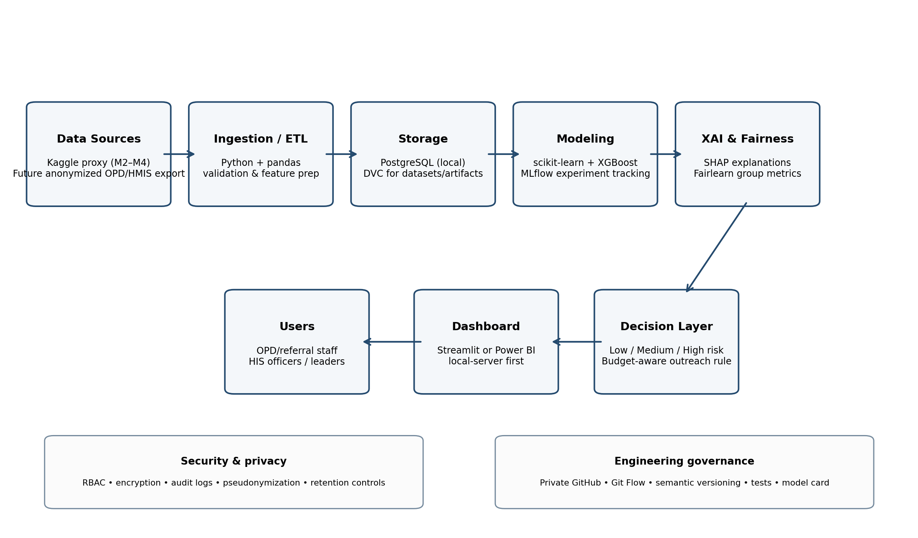
Figure 2. Target analytics architecture and data flow.

4. Agile Delivery Methodology
There is uncertainty in the project regarding data quality, the usefulness of features, the workflow of the stakeholders and the performance of fairness. Therefore, an agile approach is appropriate. Scrum, in contrast, stresses iterative delivery, inspection, and adaptation instead of waiting for a single final release (Schwaber & Sutherland, 2020). The project uses four short sprints with Kanban execution view.
Sprint 0 (Module 2: Plan and Govern) sets up the repository, architecture, data dictionary, RAID log, privacy plan and acceptance criteria. Sprint 1 (Module 3: Data Pipeline) - Ingests the proxy dataset, profiles quality, engineers scheduling features, documents transformations, and establishes a reproducible train/validation split. Sprint 2 (Module 4: Model, XAI, and Fairness) compares a transparent logistic-regression baseline to tree-based models, tunes the high-risk threshold to prioritise recall, applies SHAP, and evaluates group metrics. Sprint 3 (Module 5: Decision Support and Stakeholder Validation) builds the dashboard and outreach rules and does user acceptance testing and handover materials.
Each sprint ends with a review against a Definition of Done: code is committed and reviewed, tests pass, documentation is updated, data/model versions are traceable, and ethical or privacy gates are cleared. The Medical Director or delegated OPD lead acts as business Product Owner; the analytics lead owns technical delivery; the HIS/data officer owns data definitions and quality; the DPO/IT function owns privacy and security controls; and OPD/referral users validate workflow usability. Feedback is converted into backlog items at the next planning cycle. Appendix B maps sprint tickets to repository components and acceptance criteria.

Sprint | Goal | Key increment | Review gate
Sprint 0 / Module 2 | Plan & Govern | Repository, architecture, data dictionary, RAID, privacy/fairness acceptance criteria | Architecture and governance review
Sprint 1 / Module 3 | Data Pipeline | Ingestion, quality profiling, feature engineering, reproducible split, pipeline tests | Data-quality gate
Sprint 2 / Module 4 | Model + XAI + Fairness | Baseline and candidate model, thresholding, SHAP, Fairlearn, model card | Model/fairness gate
Sprint 3 / Module 5 | Decision Support | Risk tiers, outreach rule, dashboard, UAT, handover | Pilot readiness gate

5. Implementation, Stakeholder Communication, Monitoring, and RAID Management
Implementation proceeds through staged gates rather than immediate production deployment. Gate 1 approves the data contract and privacy controls. Gate 2 confirms that data quality is sufficient for modelling. Gate 3 requires a review of model performance, calibration, fairness and explainability. Before any live pilot, Gate 4 requires workflow usability testing and leadership approval. The proxy model therefore serves as a pilot of the methodology and is not suitable for patient-level decision making at JJUSHYCSH until it has been revalidated using appropriately governed local data.
Communication is role defined. OPD schedulers/referral coordinators receive sprint demos and test the usefulness of the ranked list. HIS/data officer during build reviews data definitions, extracts, quality checks and refreshes dashboards at least weekly. At the end of each sprint, department heads analyse trends and operational implications. Hospital administration/ Medical Director receives a monthly summary of decisions including business KPIs, major risks, and resource needs. The proposed AI and Data Governance Committee would consider privacy, feature use, fairness thresholds and any material change in score use. The Somali Regional Health Bureau only receives aggregate-only progress or performance summaries; patient-level data are not shared for routine oversight.
Monitoring combines leading and lagging indicators. Leading indicators include required-field completeness, successful daily batch execution, percentage of high-risk appointments contacted on time, and staff adoption of the outreach list. Lagging indicators include no-show rate, completed/scheduled slot utilization, model recall, precision/PR-AUC, and fairness gaps. The RAID log is reviewed during sprint planning and at release gates. Critical privacy, security, or score-misuse issues escalate immediately to the DPO/IT lead and Medical Director; data-quality issues escalate to the HIS/data officer; model/fairness issues escalate to the analytics lead and AI/Data Governance Committee. Decisions and corrective actions are converted into backlog items with owners and due points.

Stakeholder | Role | Cadence | Communication artifact
OPD schedulers / referral coordinators | Daily workflow user; validate usefulness | Weekly build check-in; sprint review | Risk list, workflow notes, UAT feedback
HIS / data officer | Data owner/steward; quality and refresh | Twice weekly during data sprint; then weekly | Data-quality report, extract log, dashboard refresh
Department heads | Service owner / capacity planning | End-of-sprint review | Department trends and operational implications
Medical Director / administration | Business sponsor / decision authority | Monthly and at release gates | KPI summary, RAID escalations, resource decisions
AI & Data Governance Committee | Privacy, ethics, fairness, change control | At data/model/pilot gates | Fairness report, feature review, compliance checklist
Somali Regional Health Bureau | Oversight stakeholder | Monthly or milestone-based | Aggregate-only progress/performance summary

6. Privacy, Fairness, Explainability, and Compliance Requirements
The privacy plan uses data minimization, purpose limitation, authorized and least-privilege access, pseudonymization, encryption in transit and at rest, retention limits, secure deletion, audit logging, and an incident-response path starting at the point where local patient data is introduced. The main legal reference for Ethiopia is the Personal Data Protection Proclamation No. 1321/2024 which is active; the project will obtain hospital legal/DPO review prior to processing a local extract (Federal Ministry of Justice, 2024). The decision to keep the production database on the hospital-controlled server in Ethiopia is a project risk-control decision that also reduces unnecessary cross-border exposure. Optional cloud mirrors are a separate transfer, security and vendor risk review.
Fairness is raised as a performance issue, not just a feature-elimination activity. The beneficial intervention is outreach, and so the key fairness goal is equal opportunity: patients that actually miss appointments should be detected at similar rates in monitored groups. Equalized odds adds false-positive-rate parity and demographic parity/selection rates are maintained as diagnostics and not considered sufficient evidence of fairness (Fairlearn, 2026). The proposed release threshold is an absolute true positive rate gap of no greater than 0.10 across gender and age bands on the proxy data and where legally and operationally available geography/distance bands on local data. We also present false-positive-rate gaps and selection-rate ratios. Silent deployment does not mean any significant difference in materials . Instead you get error analysis, feature review, threshold review, and governance signoff.
Explainability is audience-specific. Analysts receive SHAP global and local contribution analysis plus model-card documentation; OPD/referral users receive short reason codes in plain language; department heads and governance reviewers receive aggregate feature, performance, subgroup, and limitation summaries. A transparent logistic-regression baseline is retained as a comparison point, while SHAP is used for the selected model where appropriate (Lundberg & Lee, 2017). Protected attributes used for fairness auditing are separated from operational display wherever possible. The compliance checklist treats GDPR, HIPAA, and CCPA as jurisdictional screens rather than automatically applicable laws. The stricter internal rule remains constant: the score may trigger additional support, never denial, cancellation, or lower clinical priority.

Requirement | Applicability | Project control / evidence | Owner
Ethiopia Personal Data Protection Proclamation No. 1321/2024 | Primary applicable law / legal review required | Purpose limitation; minimum necessary fields; security safeguards; transparency; DPO/legal review; retention and incident procedures | Data/Privacy Lead + Hospital DPO
Hospital Research & Ethics Review | Applicable before local patient-level research/QI processing as required by hospital governance | Protocol/data use review; risk-benefit assessment; approval evidence before live local modeling | Project Lead + Ethics Committee
GDPR | Applicability screen; not assumed applicable | Reassess if project offers services to/monitors EEA persons or receives EEA-regulated data; use data-minimization principles as benchmark | Data/Privacy Lead
HIPAA | Applicability screen; not assumed applicable | Reassess if handling PHI for a U.S. covered entity/business associate; otherwise use security controls as benchmark | Data/Privacy Lead
CCPA/CPRA | Applicability screen; not assumed applicable | Reassess only if future organizational scope creates California statutory coverage | Data/Privacy Lead

7. Conclusion and Delivery Readiness
Module 2 translates the Module 1 vision into an executable, governed delivery plan. The project now has a defined business problem, testable root-cause hypotheses, measurable KPIs, data requirements, architecture, sprint structure, stakeholder communication flow, RAID process, and privacy/fairness/XAI controls. The next technical increment is the Sprint 1 data pipeline using the disclosed proxy dataset while the hospital approval pathway for a future anonymized JJUSHYCSH extract is pursued. Local deployment is conditional on data-quality, privacy, model-performance, fairness, explainability, and workflow gates. Throughout the project, the governing principle remains unchanged: prediction is used to target additional outreach and protect specialist capacity; it does not determine a patient's entitlement to care.

References
Ahmed, A. F. (2026). Project vision document: Predicting and reducing missed referral appointments at Jigjiga University Sheikh Hassan Yabare Comprehensive Specialized Hospital [Unpublished BAN6800 Module 1 assignment]. Nexford University.
CURE Ethiopia. (2023, August 29). New mobile clinic in Jigjiga. https://ethiopia.cure.org/news/new-mobile-clinic-in-jigjiga/
Fairlearn. (2026). Common fairness metrics. https://fairlearn.org/main/user_guide/assessment/common_fairness_metrics.html
Federal Ministry of Justice, Ethiopia. (2024). Personal Data Protection Proclamation No. 1321/2024. https://justice.gov.et/en/law/personal-data-protection-proclamation/
Hoppen, J. (2016). Medical appointment no shows [Data set]. Kaggle. https://www.kaggle.com/datasets/joniarroba/noshowappointments
Jigjiga University Sheikh Hassan Yabare Comprehensive Specialized Hospital. (n.d.). About us. https://www.shycsh.edu.et/about
Lundberg, S. M., & Lee, S.-I. (2017). A unified approach to interpreting model predictions. Advances in Neural Information Processing Systems, 30.
Schwaber, K., & Sutherland, J. (2020). The Scrum Guide. https://scrumguides.org/docs/scrumguide/v2020/2020-Scrum-Guide-US.pdf
Nexford University. (2026). BAN6800 Module 2 assignment: Business Analytics Project Overview Report [Course assignment instructions and rubric].

Appendix A. Repository, Environment, and Deliverables
The repository structure below follows the Module 1 design and is mirrored in the accompanying project starter package. It contains requirements.txt, a preliminary data dictionary, the sprint-ticket register, and the technical RAID log. Non-public project material should remain in a private repository with access limited to authorized collaborators.
jjushycsh-noshow-analytics/
├── README.md
├── requirements.txt
├── .gitignore
├── data/
│ ├── raw/
│ ├── processed/
│ └── external/
├── notebooks/
├── src/
│ ├── data_prep/
│ ├── features/
│ ├── models/
│ └── dashboard/
├── docs/
│ ├── data_dictionary.md
│ ├── ethics_risk_register.md
│ └── ai_disclosure.md
├── tests/
└── .dvc/

Environment File (requirements.txt)
pandas>=2.2
numpy>=1.26
scikit-learn>=1.5
xgboost>=2.1
mlflow>=2.15
shap>=0.46
fairlearn>=0.11
streamlit>=1.38
matplotlib>=3.9
psycopg2-binary>=2.9
python-dotenv>=1.0
jupyterlab>=4.2
dvc>=3.55
pytest>=8.0

Appendix B. GitHub Project Board Ticket Register
ID | Sprint | Ticket | Status | Acceptance criterion
S0-01 | Sprint 0 | Initialize repository and Git Flow | Prepared locally | Repo contains agreed structure and README
S0-02 | Sprint 0 | Create architecture diagram | Prepared locally | All components and data flows documented
S0-03 | Sprint 0 | Approve privacy and data-minimization plan | Prepared for review | Required fields, roles, security, retention defined
S0-04 | Sprint 0 | Create RAID register | Prepared for review | Owner, trigger, mitigation, status recorded
S0-05 | Sprint 0 | Create preliminary data dictionary | Prepared for review | Proxy and future local fields documented
S1-01 | Sprint 1 | Ingest Kaggle proxy data | Backlog | Raw file immutable; schema validation passes
S1-02 | Sprint 1 | Profile data quality | Backlog | Missingness, invalid ages/dates, duplicates documented
S1-03 | Sprint 1 | Engineer scheduling features | Backlog | Lead time, day-of-week, age bands reproducible
S1-04 | Sprint 1 | Build testable preprocessing pipeline | Backlog | Unit tests and versioned processed data
S2-01 | Sprint 2 | Train transparent baseline | Backlog | Logistic regression metrics logged in MLflow
S2-02 | Sprint 2 | Train candidate tree model | Backlog | XGBoost comparison documented
S2-03 | Sprint 2 | Select high-risk threshold | Backlog | Recall ≥70% or limitation explicitly documented
S2-04 | Sprint 2 | Run fairness assessment | Backlog | TPR/FPR/selection metrics by group reported
S2-05 | Sprint 2 | Generate SHAP analysis and model card | Backlog | Global/local explanations and limitations recorded
S3-01 | Sprint 3 | Implement outreach rules | Backlog | Risk tier maps to approved support action only
S3-02 | Sprint 3 | Build dashboard prototype | Backlog | Role-based views and KPI monitoring available
S3-03 | Sprint 3 | Conduct UAT and workflow review | Backlog | User feedback logged and critical defects resolved
S3-04 | Sprint 3 | Pilot-readiness governance gate | Backlog | Privacy/fairness/operations sign-off recorded

Appendix C. Technical RAID Log
ID | Type | Item | Likelihood | Impact | Mitigation / response | Owner | Status
R-01 | Risk | Local data access delayed | High | High | Continue proxy methodology; start governance request early; no local deployment without approved extract | Project Lead | Open
R-02 | Risk | Brazil proxy does not generalize to Jigjiga | High | High | Treat as methodology pilot; revalidate and recalibrate on local data | Analytics Lead | Open
R-03 | Risk | Incomplete or inconsistent local digitization | High | High | Define minimum viable schema; data-quality gate; manual reconciliation plan | HIS/Data Officer | Open
R-04 | Risk | Risk score is misused to deprioritize care | Medium | High | Policy: score only triggers support; role-based display; audit actions; governance review | Medical Director | Open
R-05 | Risk | Patient contact/scheduling data exposed | Low-Med | High | Encryption, RBAC, audit logs, pseudonymization, incident response | DPO / IT | Open
R-06 | Risk | Connectivity disrupts cloud dashboard | Medium | Medium | Local-first deployment; offline/exportable summaries | IT Lead | Open
A-01 | Assumption | Appointment outcome is recorded reliably enough to train a label | Medium | High | Validate label completeness in Module 3; revise scope if unreliable | HIS/Data Officer | Open
A-02 | Assumption | Reminder/outreach channels are available for targeted use | Medium | Medium | Confirm staffing/SMS/phone constraints before prescriptive rules | OPD Lead | Open
I-01 | Issue | No verified JJUSHYCSH no-show baseline in Module 2 | Current | High | Establish baseline from approved historical OPD registers/extract in Module 3 | Project Lead | Open
D-01 | Dependency | Ethics/privacy/legal approval for local patient data | Critical | High | No local patient-level modeling before required approvals | Project Lead / DPO | Open
D-02 | Dependency | Hospital-controlled compute/storage for live pilot | Medium | High | Confirm server, backups, accounts, and recovery procedure before Gate 4 | IT Lead | Open

Appendix D. Preliminary Data Dictionary
Field | Source | Type | Meaning | Planned handling
PatientId | Proxy | Numeric/ID | Patient identifier | Pseudonymous modeling key; do not expose in dashboard
AppointmentID | Proxy | Numeric/ID | Appointment identifier | Primary appointment-level key
Gender | Proxy | Categorical | Recorded sex/gender | Model candidate + fairness audit; review necessity
ScheduledDay | Proxy | Datetime | Date appointment was scheduled | Derive scheduling lead time
AppointmentDay | Proxy | Datetime | Date of actual appointment | Outcome timing / lead time
Age | Proxy | Integer | Patient age | Validate range; create age bands for fairness
Neighbourhood | Proxy | Categorical | Appointment location/neighbourhood | Proxy-specific; not directly mapped to Jigjiga residence
Scholarship | Proxy | Binary | Brazil welfare-program indicator | Context-specific; may not transfer to Ethiopia
Hipertension | Proxy | Binary | Hypertension flag | Clinical history feature; spelling preserved from dataset
Diabetes | Proxy | Binary | Diabetes flag | Clinical history feature
Alcoholism | Proxy | Binary | Alcoholism flag | Sensitive/contextual feature; necessity review
Handcap | Proxy | Integer/Binary | Disability indicator | Sensitive feature; careful necessity/fairness review
SMS_received | Proxy | Binary | Whether one or more SMS reminders were received | Intervention-related predictor
No-show | Proxy | Categorical target | Attendance outcome | Normalize to no_show = 1 when patient missed

Future Local JJUSHYCSH Minimum Data Contract (subject to approval)
Field | Source | Type | Meaning | Status
appointment_id | Local OPD/referral | ID | Unique appointment key | Required
patient_pseudo_id | Local OPD/referral | ID | Pseudonymous patient key for repeat history | Required if repeat-history feature is approved
scheduled_datetime | Local OPD/referral | Datetime | Scheduling timestamp | Required
appointment_datetime | Local OPD/referral | Datetime | Planned visit timestamp | Required
attendance_status | Local OPD/referral | Categorical | Completed / missed / cancelled | Required target; cancellation handled separately
department/service | Local OPD/referral | Categorical | Receiving specialty/service | Required for service-level monitoring
referral_source | Local OPD/referral | Categorical | Referring facility/type | Useful for referral-path analysis
age / age_band | Local OPD/referral | Numeric/Categorical | Patient age | Model + fairness monitoring as approved
gender | Local OPD/referral | Categorical | Recorded gender/sex | Fairness monitoring; model use requires review
distance_band / residence geography | Local OPD/referral | Categorical | Coarse access/geography indicator | Audit and support targeting; never deprioritization
contact_available | Local OPD/referral | Binary | Usable phone/contact on record | Operational outreach field
reminder_type_sent | Outreach log | Categorical | SMS / phone / CHW / none | Intervention tracking
outreach_datetime | Outreach log | Datetime | Time of contact attempt | Timeliness KPI
outreach_outcome | Outreach log | Categorical | Reached / not reached / rescheduled | Feedback/retraining and operations

